Grid Layout Design

Definition
# Source: AI Source: Provided by: [Data Path: Persons Table -> ID Column: 1, Name_En Column: Motasem Essam] -> From: [Chatgpt (GPT‑5 Mini)] on [2/12/2026]
Grid Layout Design is a web design technique that organizes content on a webpage into rows and columns, creating a structured and balanced layout.

Simple Definition
# Source: AI Source: Provided by: [Data Path: Persons Table -> ID Column: 1, Name_En Column: Motasem Essam] -> From: [Chatgpt (GPT‑5 Mini)] on [2/12/2026]
Grid Layout Design = arranging website content using a system of rows and columns.

How Grid Layout Design Works
# Source: AI Source: Provided by: [Data Path: Persons Table -> ID Column: 1, Name_En Column: Motasem Essam] -> From: [Chatgpt (GPT‑5 Mini)] on [2/12/2026]
• The page is divided into a grid of rows and columns
• Content (text, images, buttons) is placed inside grid sections
• Uses CSS Grid or similar layout systems
• Helps align elements neatly and consistently

Purpose of Grid Layout Design
# Source: AI Source: Provided by: [Data Path: Persons Table -> ID Column: 1, Name_En Column: Motasem Essam] -> From: [Chatgpt (GPT‑5 Mini)] on [2/12/2026]
• Create a clean and organized structure
• Improve visual consistency
• Make the design easier to read and follow
• Help align elements properly
• Improve user experience

Advantages
# Source: AI Source: Provided by: [Data Path: Persons Table -> ID Column: 1, Name_En Column: Motasem Essam] -> From: [Chatgpt (GPT‑5 Mini)] on [2/12/2026]
• Clean and professional look
• Easy to organize content
• Responsive and flexible
• Improves readability
• Saves time in design

Disadvantages
# Source: AI Source: Provided by: [Data Path: Persons Table -> ID Column: 1, Name_En Column: Motasem Essam] -> From: [Chatgpt (GPT‑5 Mini)] on [2/12/2026]
• Can be complex to learn and implement, especially for beginners
• Requires good planning to design an effective grid structure
• Not always flexible for very unique or creative layouts
• Can become complicated when handling many nested grids
• May require more code and understanding of CSS Grid properties
• Difficult to maintain in very large and complex designs if not organized properly
• Can feel restrictive if not used correctly or if over-structured

Examples
# Source: AI Source: Provided by: [Data Path: Persons Table -> ID Column: 1, Name_En Column: Motasem Essam] -> From: [Chatgpt (GPT‑5 Mini)] on [2/12/2026]
• A blog page with articles arranged in columns
• A photo gallery displayed in a grid format
• A product page with items aligned in rows and columns
• News websites with structured sections

Difference Between Grid Layout Design and Other Techniques
# Source: AI Source: Provided by: [Data Path: Persons Table -> ID Column: 1, Name_En Column: Motasem Essam] -> From: [Chatgpt (GPT‑5 Mini)] on [2/12/2026]
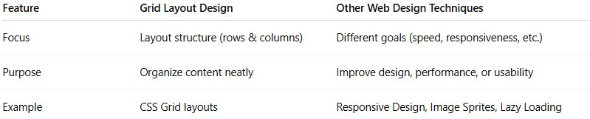
Feature | Grid Layout Design | Other Web Design Techniques
Focus | Layout structure (rows & columns) | Different goals (speed, responsiveness, etc.)
Purpose | Organize content neatly | Improve design, performance, or usability
Example | CSS Grid layouts | Responsive Design, Image Sprites, Lazy Loading

